

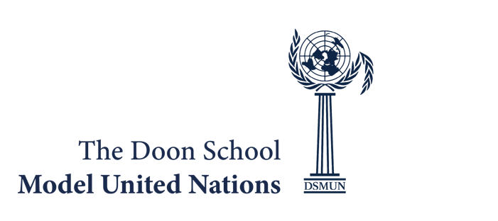
THE DOON SCHOOL
MODEL UNITED NATIONS CONFERENCE 2026
16th – 18th August
DELEGATION INFORMATION FORM
Name of School:
Delegation Information:-
S.No | Name | Gender (M/F/Any Other) | Grade | Age | Email | Whatsapp Number | Committee  Preference
1.
2.
3.
4.
5.
6.
7.
8.
9.
10.
11.
12.
13.
14.
15.

Name of Escort(s):
Gender (M/F/Any Other):
Whatsapp Number:
E-Mail ID:

*Even though we shall endeavor to meet your committee preferences, we do not guarantee that all committee preferences will be met. All committees are mentioned in the website, so we request you to use the committee abbreviations to mention the preferences.

