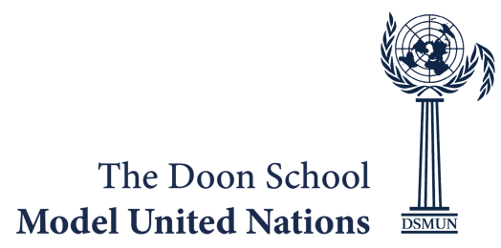
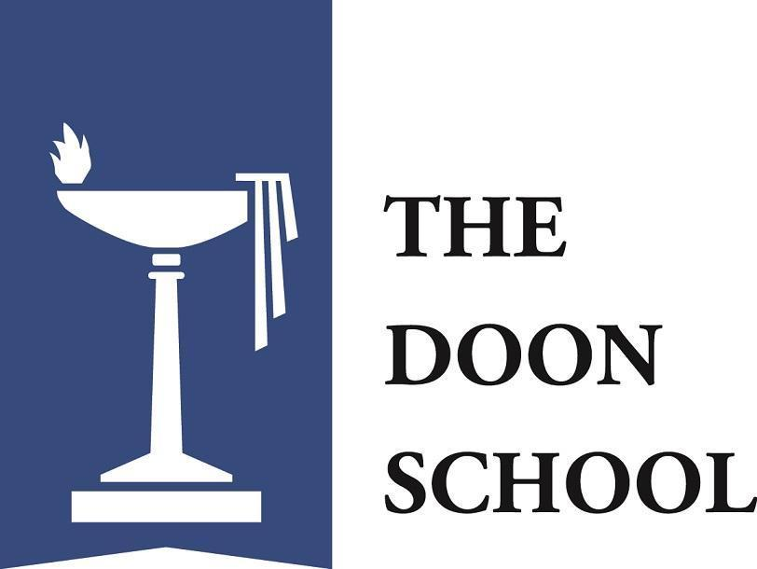
Indemnity Form

I, ________________________ , the Head of ________________________
(School Name), give consent for my school delegation comprising _______
delegates to participate in the Doon School Model United Nations conference
2026 to be held from the 16th to 18th of August, 2026 at The Doon School,
Dehradun.

I hereby agree to adhere to the policies and rules of the conference outlined in
the Conference Policy of DSMUN 2026 and also agree that all students and
faculty advisors will be aware and shall adhere to the Conference Policy. In case
of any failure to do so, I shall have no objections if a student or the delegation is
suspended from the conference.

We understand that DSMUN 2026 will be held at The Doon School, Dehradun
and we shall not hold The Doon School responsible for any untoward incident
that may occur during the conference.

The Doon School
Mall Road
Dehradun, UK 248 003
India
Phone: +91 135-2526400
Fax: +91 135 1757275
Email: info@doonschool.com
www.doonschool.com
The Indian Public Schools’ Society Registered Office: The Doon School,
Chandbagh, Dehradun, Uttarakhand
Corporate Identification No.: U99999UR1928NPL002455

